**QUERY1**

SELECT

customer.name, customer.addr1, customer.city, customer.state, customer.zip,

invoicehdr.invoiceID , incvoicehdr.saleDate, invoicedtl.prodID , invoiceDTL.amt, invoicedtl.qty,

FROM customer INNER JOIN invoicehdr ON customer.customerID = invoicehdr.customerID

INNER JOIN invoicedtl ON invoicehdr.invoiceID= invoicedtl.invoiceID

WHERE customer.name LIKE "Camera Platforms International Inc%" ;

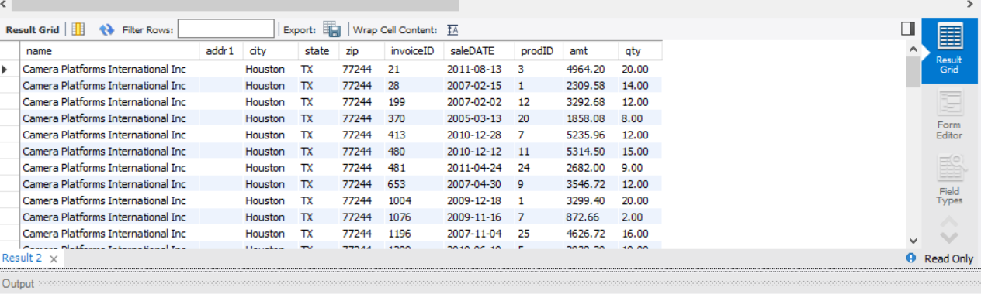

**QUERY2**

SELECT YEAR(saleDate), abbrev, sum(invoicedtl.amt*invoicedtl.qty) as "Total Sales "

FROM business_unit

INNER JOIN prodtype ON prodtype.buid = business_unit.buid

INNER JOIN product ON product.prodTypeID=prodtype.prodTypeID

INNER JOIN invoicedtl ON invoicedtl.prodID=product.prodID

INNER JOIN invoicehdr ON invoicehdr.invoiceID=invoicedtl.invoiceID

GROUP BY YEAR(saleDate), business_unit.abbrev

ORDER BY YEAR(saleDate) , business_unit.abbrev;

